**ELEVATI** **ON SYSTEM**

**\*\*\*\*\*\***

**Manual Guide**

Contents

**I. Login:** 2

**II. Login as Employee:** 3

**III. Login as admin:** 8

**I. Login:**

1. Start running the Application, the form Login will appear: 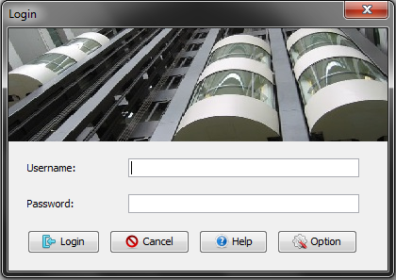

2. Before you login, you will need to connect to database by click “Option” button.  
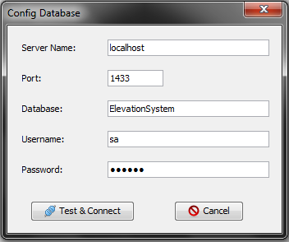

Then you have to type Server name, Port, Database, Username, and Password to login to SQL Server, click “Test & Connect” button to connect. If it appears: “Successful Connection” the login form will appear again and you have to type Username and password.

**II. Login as Employee:**

Employee Main

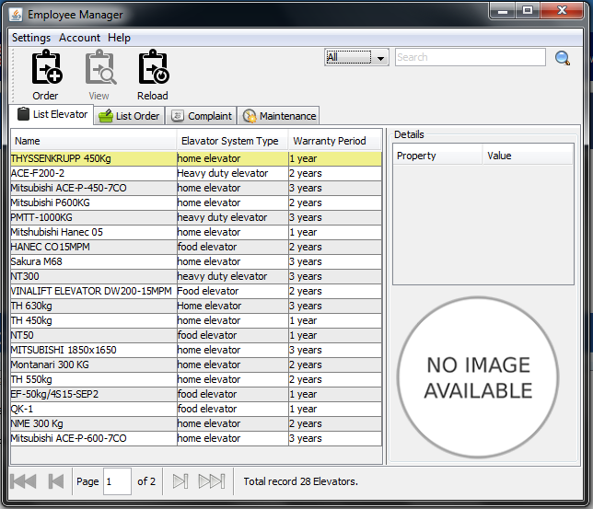

1. To Order elevator:  
-Choose one or more elevator.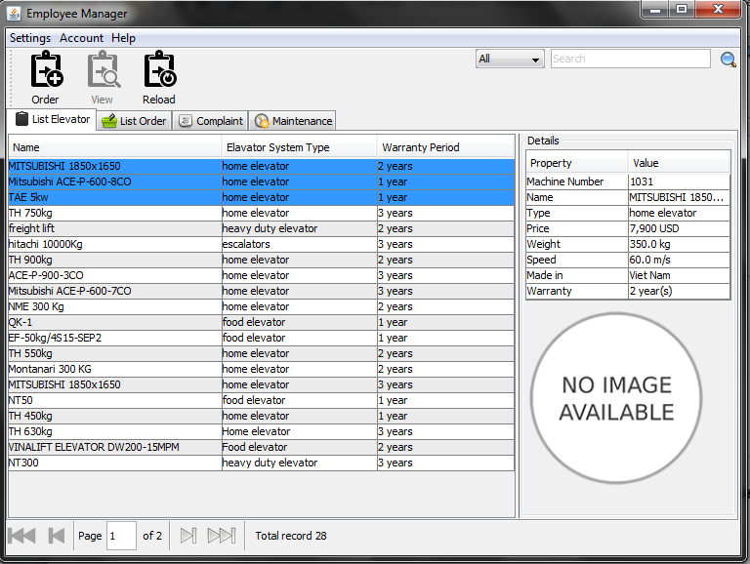

-Then Click on “Order” button, a new window will pop-up.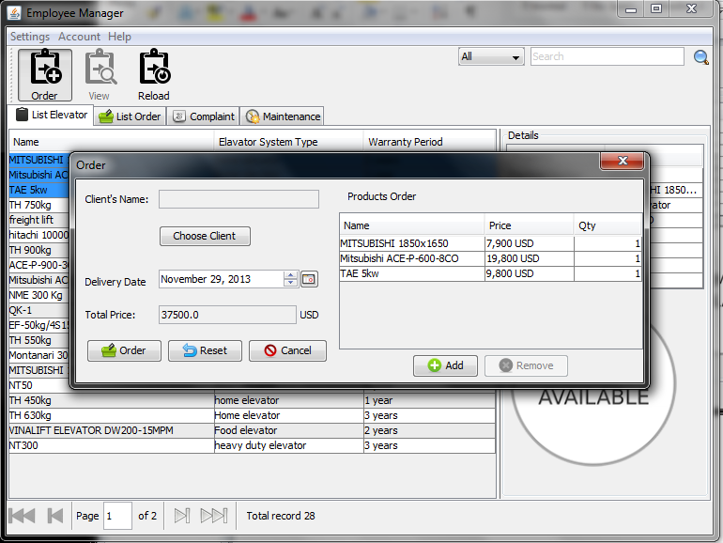

-Click “Choose Client” button to select client or you can add a new client.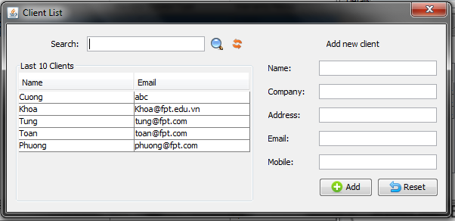

-Choose ”Delivery Date”, then click on ”Order”.

2. Move to “List Order” tab to Bill or Cancel order.  
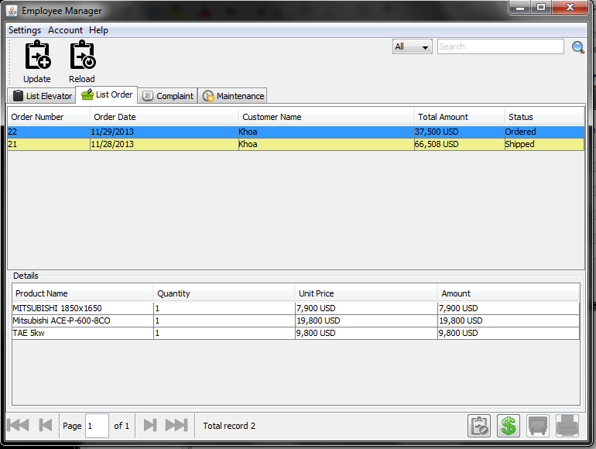

3. After bill, you can print by click on” Print” button.  
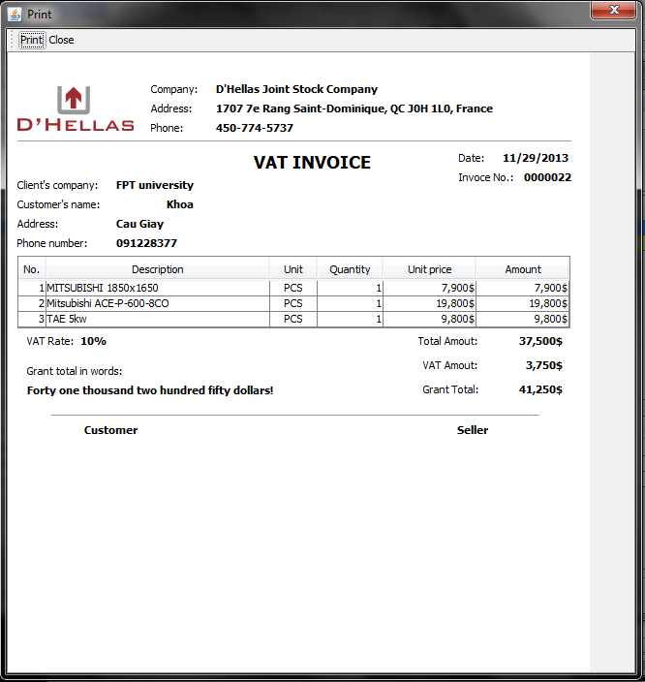

4. To view account’ s information or change password, click on “Account” button. 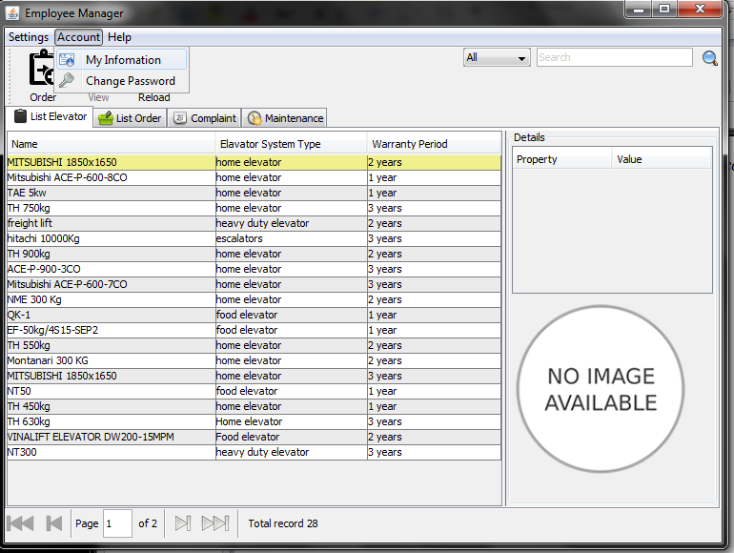

**III. Login as admin:**

Admin main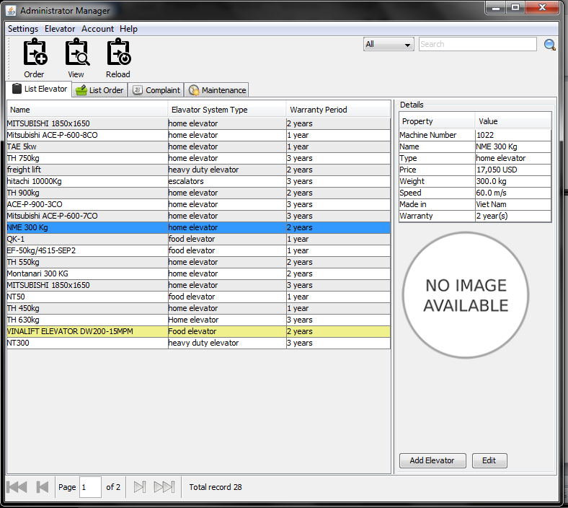

1. To add a new elevator, click on “Add Elevator”.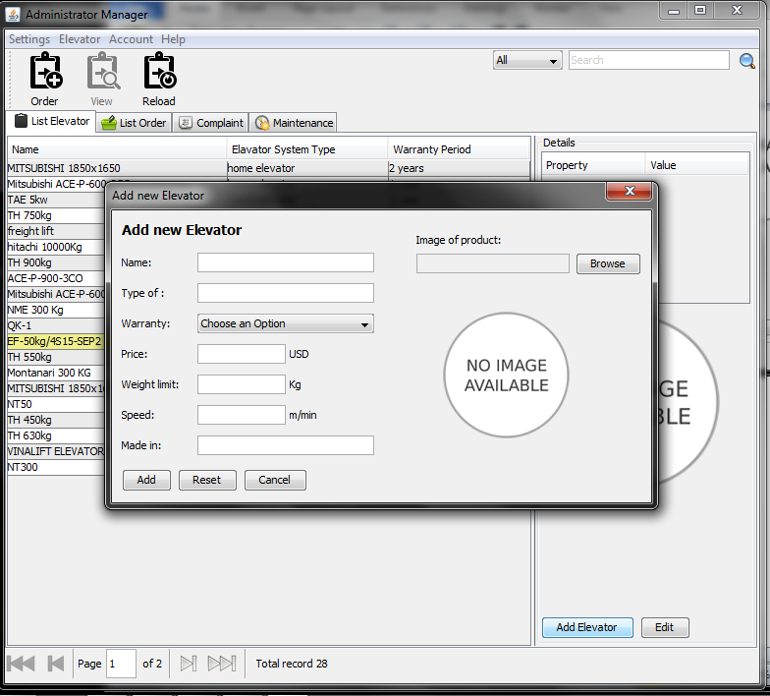

2. To edit elevator’s information, choose an elevator then click on ”Edit” button.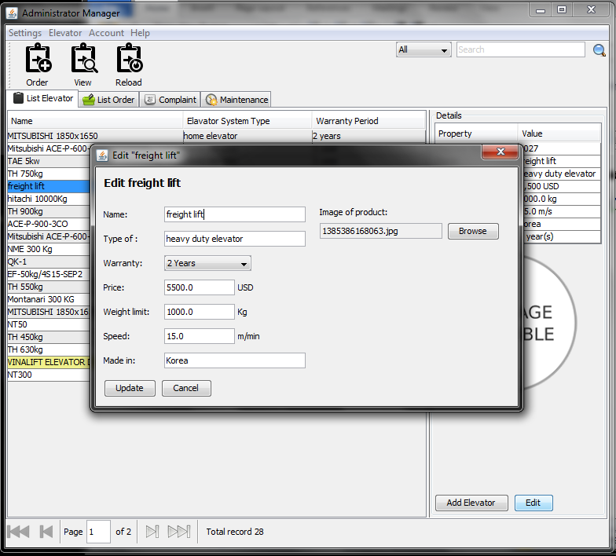

3. You can change password or view information by click on “Account” button.